**National University of Computer and Emerging Sciences**



Laboratory Manual

for

Data Structures Lab

|  |  |
| --- | --- |
| Course Instructor | **Samman Ashraf** |
| Lab Instructor(s) | Muhammad Ahmed  Hamza Ayub |
| Section | 4N1 – 4N2 |
| Semester | Spring 2023 |

**Department of Computer Science**

FAST-NU, Lahore, Pakistan

**Objectives:**

In this lab, students will practice:

1. Singly Linked List

**Linked list Data Structure**

In this tutorial, you will learn about linked list data structure and it's implementation in Python, Java, C, and C++.

A linked list is a linear data structure that includes a series of connected nodes. Here, each node stores the data and the address of the next node. For example,

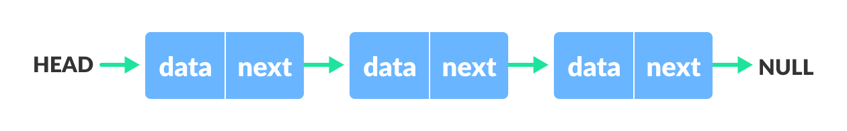Linked list Data Structure

You have to start somewhere, so we give the address of the first node a special name called HEAD. Also, the last node in the linked list can be identified because its next portion points to NULL.

Linked lists can be of multiple types: singly, doubly, and circular linked list. In this article, we will focus on the singly linked list

**Question 1**

1. Implement a template class ‘Node’ that contains two data members: A template variable ‘data’ and a Node pointer ‘next’. You may define any member functions, if required, for the template class.
2. Now using the above class, implement a singly linked list which supports the following operations:
3. Insert at start void insertAtStart(T const element);
4. Insert at end void insertAtEnd(T const element);
5. Print void print() const;
6. Search an element bool search(T const& element) const;
7. Check whether the list is empty bool isEmpty() const;
8. Insert value v1 before value v2 bool insertBefore(T const v1, T const v2 ) const;
9. Delete all occurrences of a given value void deleteAll(T const value)
10. Destructor
11. Delete from Start void DeleteAtStart();
12. Now create a main function which has the following instructions:
    1. Define a linked list object of type int.
    2. Insert 2, 6, and 7 at start
    3. Insert 9 at the end.
    4. Now insert 7, 8, and 9 at start.
    5. Delete all occurrences of 7.
    6. Now print the linked list.
    7. Search for 2, 9 and 10.
    8. Now delete from Start and print the linked list.

**Question 2**

Now write a member function reverse which reverses the linked list.